Borwell Software Challenge – Testing Documentation

Noah Barnett

Contents

Introduction 2

Test Log 2

Appendix 1 5

Appendix 2 8

Appendix 3 10

Appendix 4 11

Appendix 5 12

Appendix 6 14

Appendix 7 15

Appendix 8 18

Appendix 9 20

Appendix 10 20

Appendix 11 24

Appendix 12 26

# Introduction

This document will cover the testing conducted on the final product of the Borwell software challenge, called the paint calculator.

# Test Log

|  |  |  |  |  |  |  |
| --- | --- | --- | --- | --- | --- | --- |
| **Test No.** | **Page Tested** | **Element Tested** | **Expected Outcome** | **Actual Outcome** | **Pass / Fail** | **Evidence** |
| 1. | Results + Room (class) | Calculations | The walls area/volume and paint calculations are correct, and displayed on the results page | The walls area and volume is calculated accurately and displayed on the results page. The paint calculation takes into account the area taken up by doors and windows and the ratio between wall space and litres of paint as well as rounding up to the nearest litre, which produces an accurate result | Pass | Appendix 1 |
| 2. | Homepage | Validation | The textboxes will only accept numerical values | The textboxes don’t accept any input other than numerical values (including decimals) and displays a message box informing the user of such if they attempt to submit these values | Pass | Appendix 2 |
| 3. | Homepage | Validation | The textboxes will only accept values up to 5 digits | The textboxes only allow values of a maximum of 5 characters | Pass | Appendix 3 |
| 4. | Homepage | Validation | All decimal values entered will be rounded to two decimal places | Any decimal value is rounded to two decimal places | Pass | Appendix 4 |
| 5. | Openings | Validation | The textboxes will only accept numerical values | The textboxes don’t accept any input other than numerical values (including decimals) and displays a message box informing the user of such if they attempt to submit these values | Pass | Appendix 5 |
| 6. | Openings | Validation | The textboxes will only accept values up to 5 digits | The textboxes only allow values of a maximum of 5 characters | Pass | Appendix 6 |
| 7. | Openings | Validation | The total area of the entered openings cannot exceed the total area of wall space | If the input in the textboxes leads to the total opening are value being greater than the total wall area, then a message box is displayed, and the input is not submitted | Pass | Appendix 7 |
| 8. | Openings | Validation | All decimal values entered will be rounded to two decimal places | Any decimal value is rounded to two decimal places | Pass | Appendix 8 |
| 9. | All | Form changes | When a new form opens, the previously form will close | The initial form remains open the entire time. The openings form can be opened from the homepage and can only be closed by clicking the ‘Previous Page’ button on it. the results page can be opened from the openings page using the ‘Submit’ button at any time. The results page can only then be closed by clicking the ‘Return to Calculator’ button. The entire application closes when the close button on the homepage is clicked | Fail | Appendix 9 |
| 10. | Openings | List of openings | When the form is closed, the list of openings will reset | When the ‘Previous Page’ button is clicked, the held list and total area of openings is reset to zero | Pass | Appendix 10 |
| 11. | Homepage | List of measurements | When a set of measurements is entered, it overwrites any previously entered measurements | The first valid input unlocks the ‘Next Page’ button, any valid input after this overwrites the data in the list and class and the ‘Next Page’ button remains unlocked. | Pass | Appendix 11 |
| 12. | Homepage | Must input data | If there I no input for the measurements of the room, the user is unable to continue through the application | The ‘Next Page’ button on the homepage is disabled until valid data is submitted | Pass | Appendix 12 |

## Appendix 1

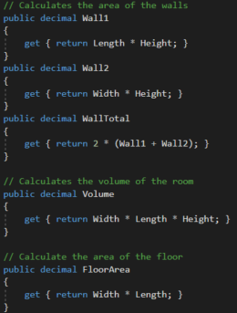

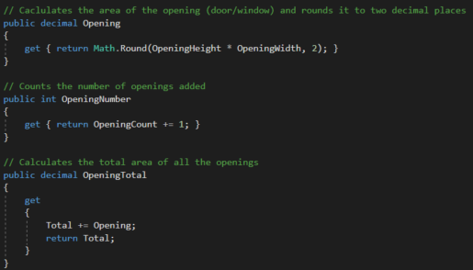

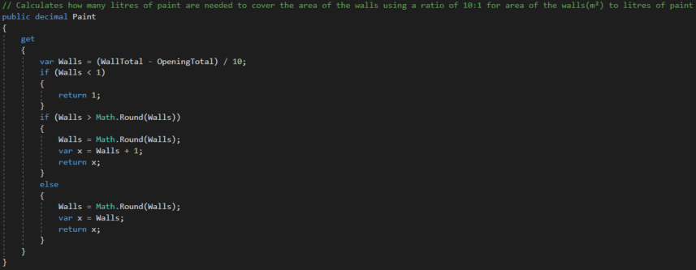

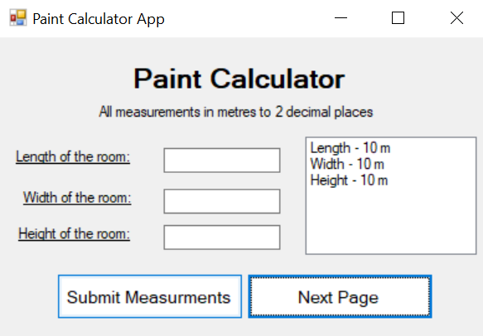

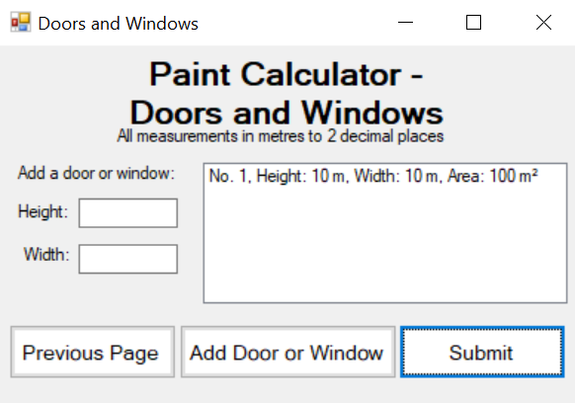

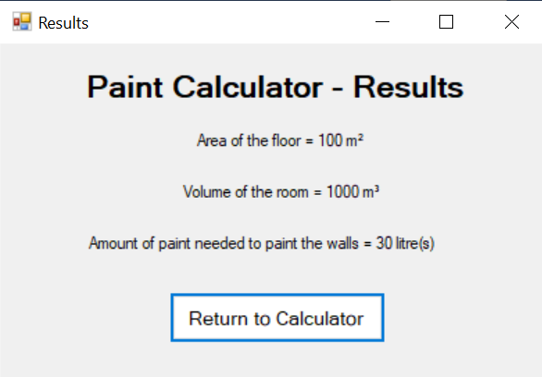

## Appendix 2

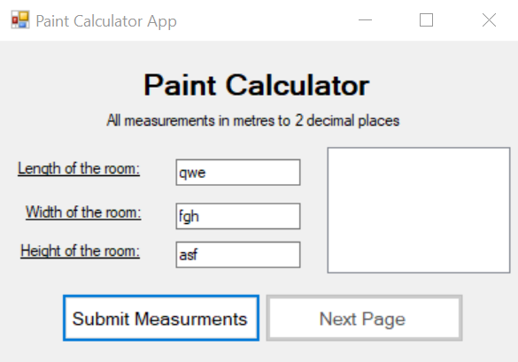

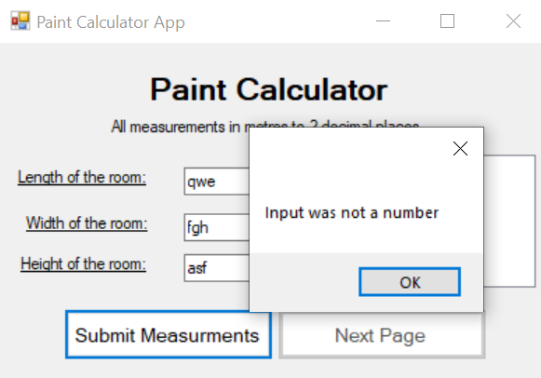

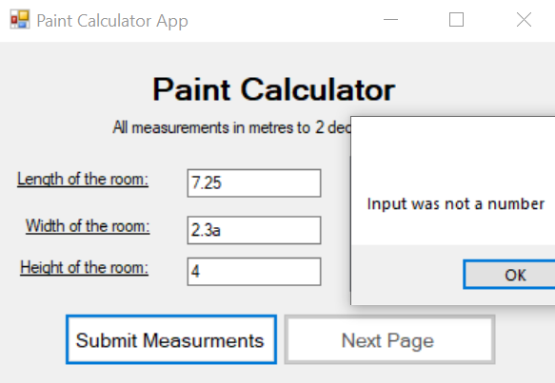

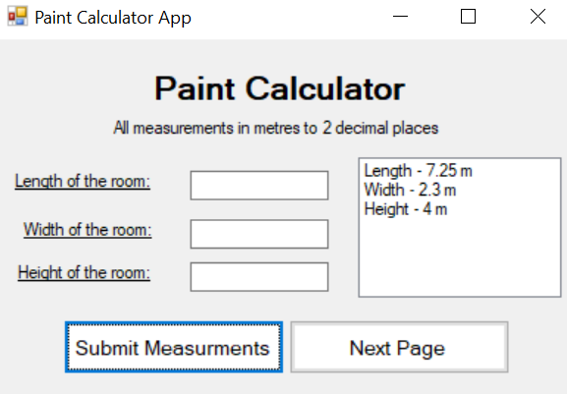

## Appendix 3

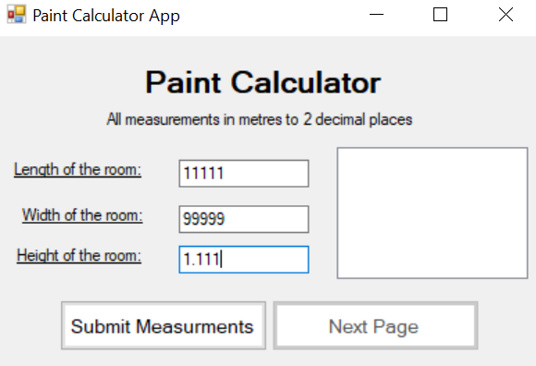

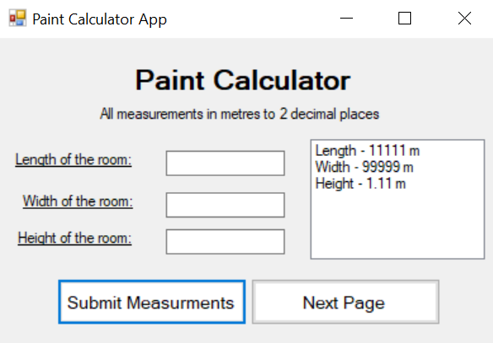

## Appendix 4

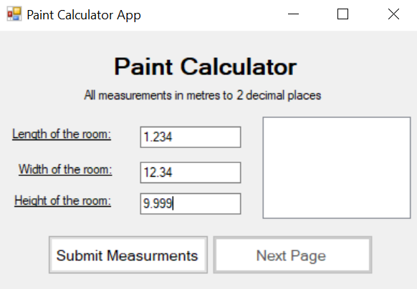

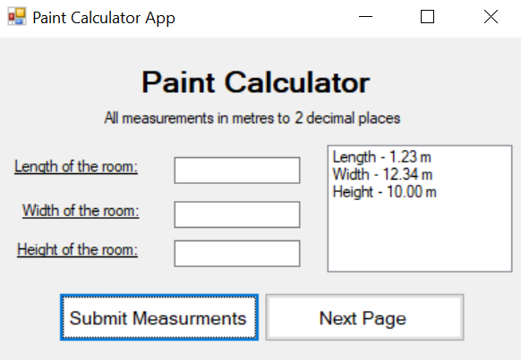

## Appendix 5

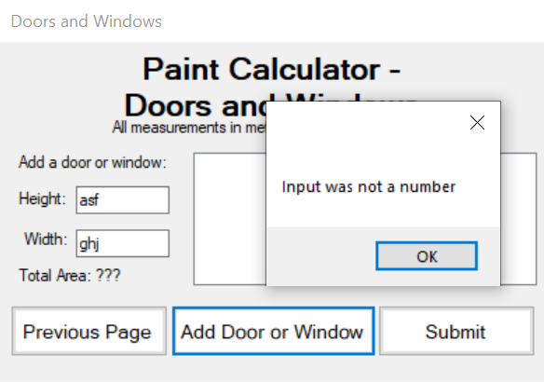

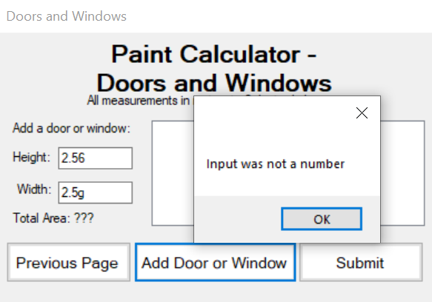

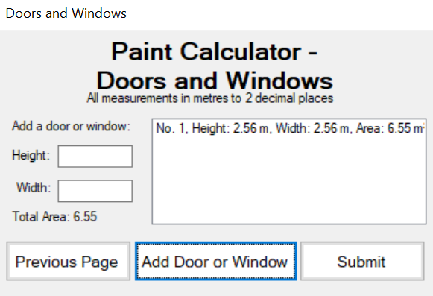

## Appendix 6

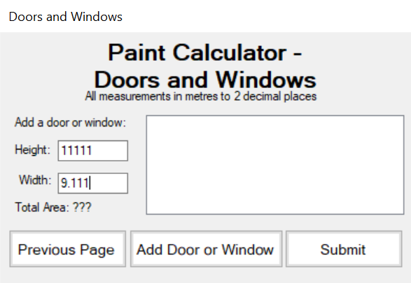

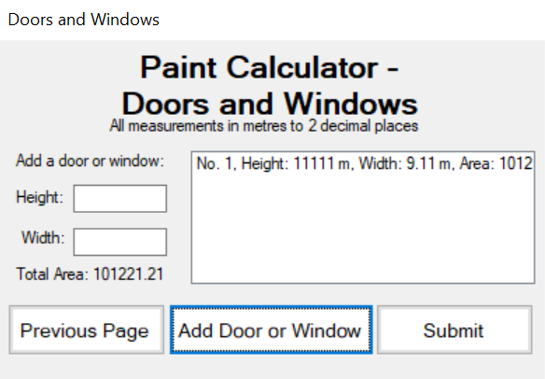

## Appendix 7

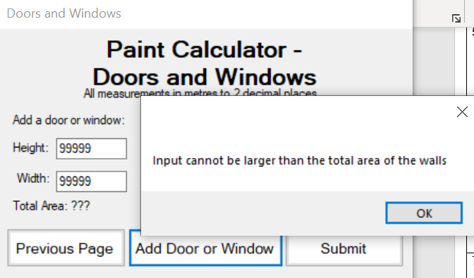

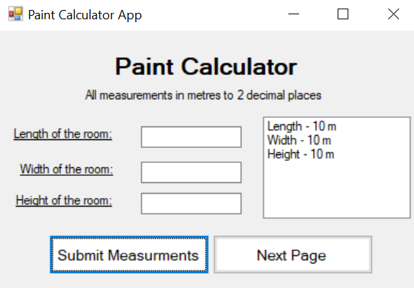

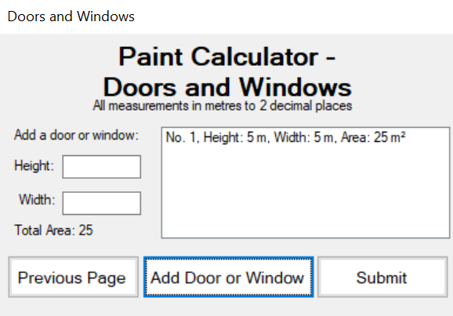

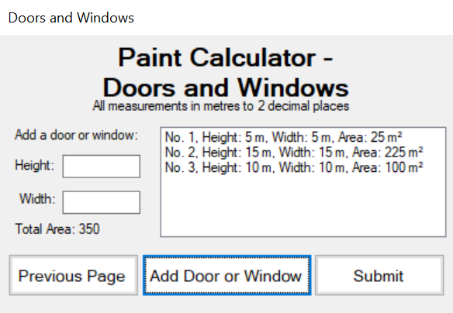

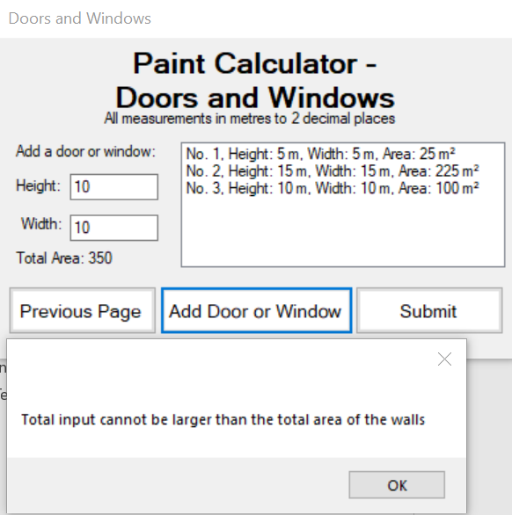

## Appendix 8

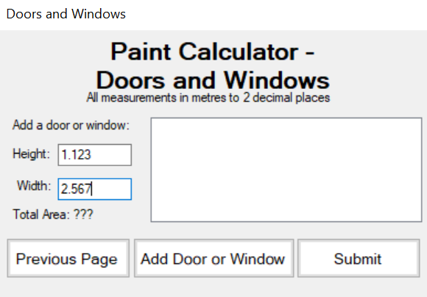

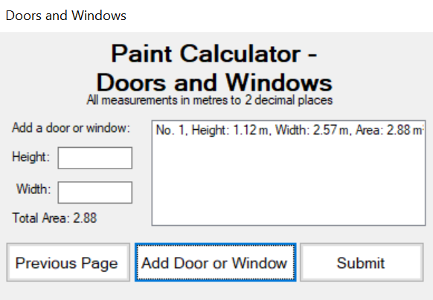

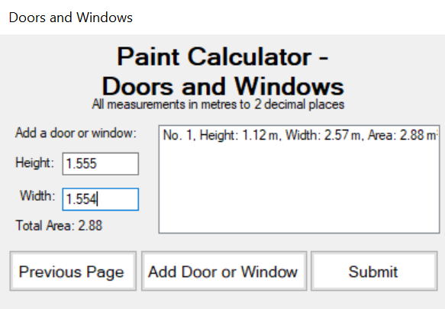

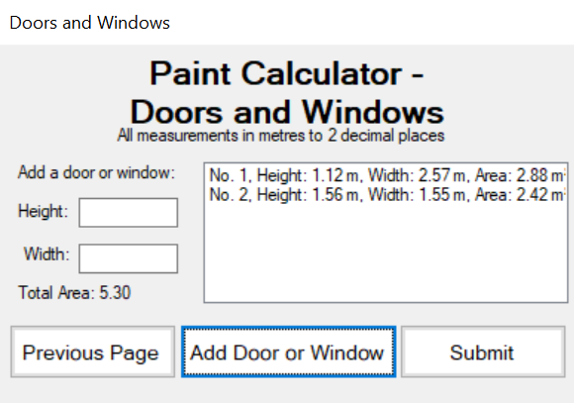

## Appendix 9

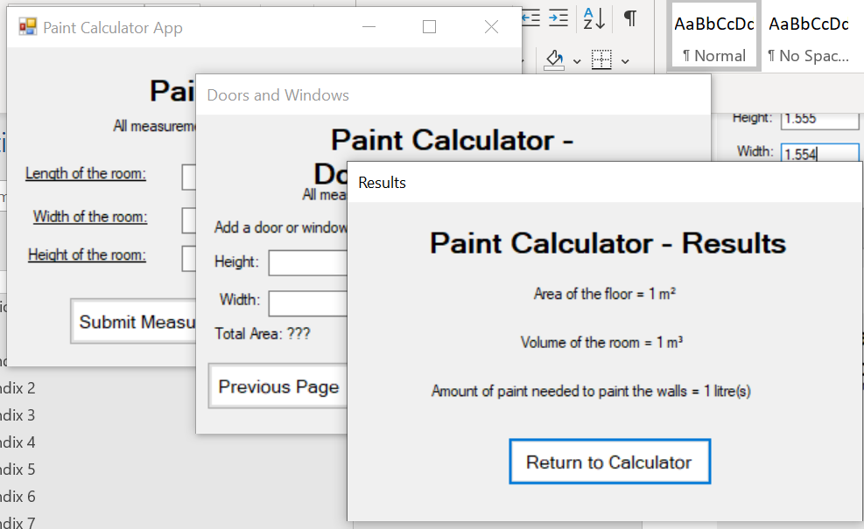

## Appendix 10

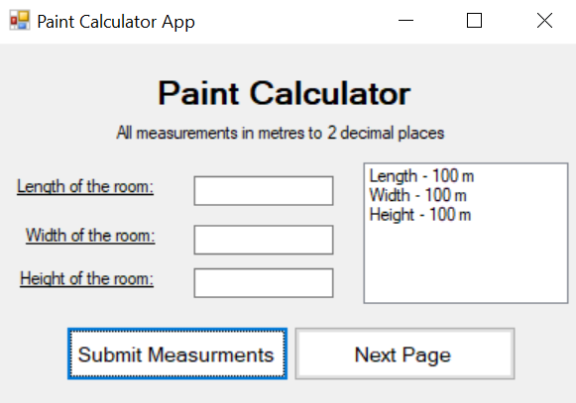

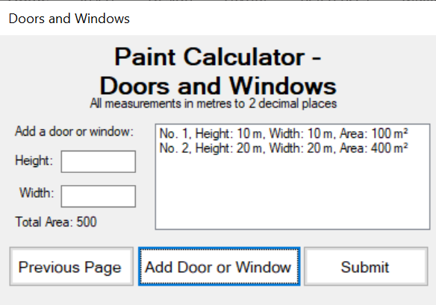

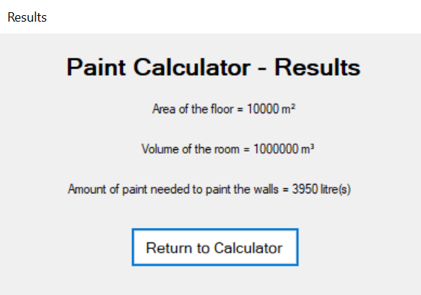

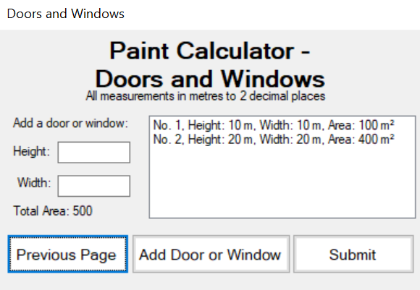

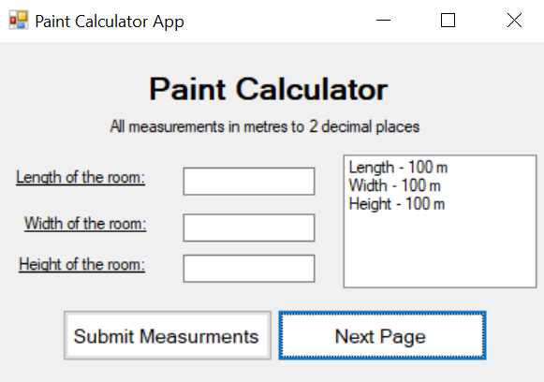

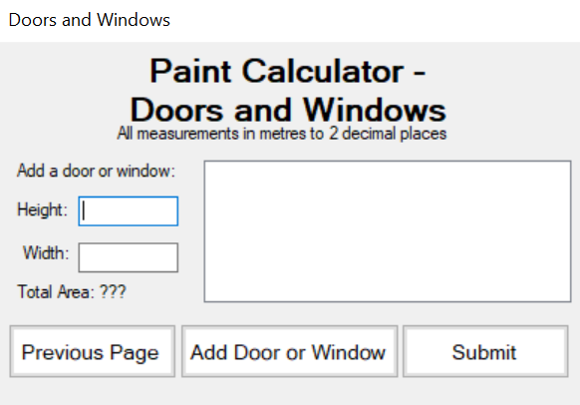

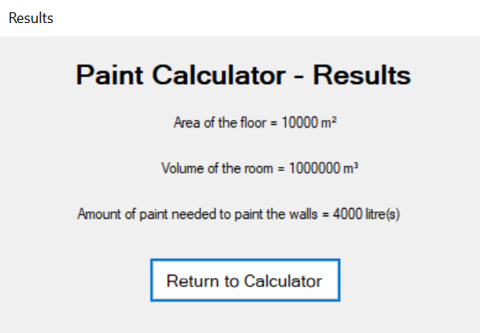

## Appendix 11

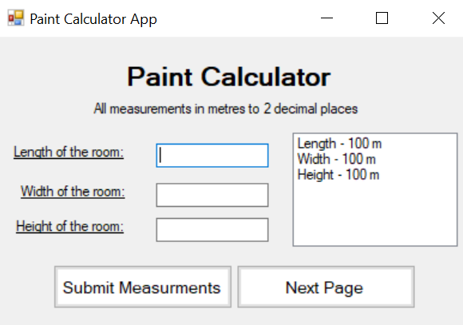

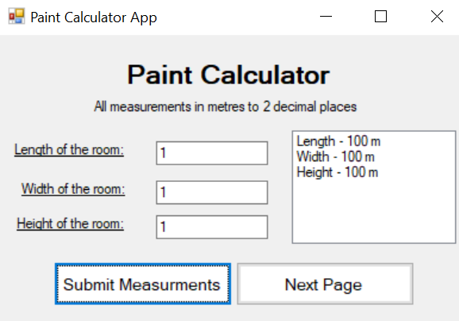

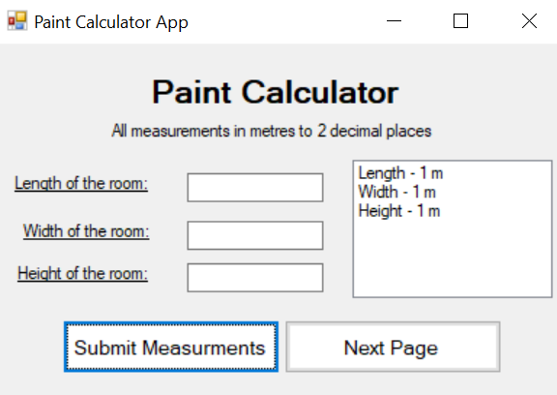

## Appendix 12

